102年放射腫瘤科專科醫師甄審
考前題庫出題格式說明

※請依照下列步驟將考題繕打於下一頁:
- 請依下一頁範例格式繕打考題。
- 本格式已設定好樣式，故請依下一頁範例格式繕打，切勿更改其樣式。
- 開始撰打考題→先於工作列上點選”格式”，下拉式選單中點選”樣式與格式”，該樣式的格式設定將會出現在螢幕的右方，請使用該格式來控制考題的格式。
      - 點選Question:可用來控制題號(題目)
      - 點選Choice:可用來控制答案選項，自動產生A) B) C) D)，若續按Enter會繼續產生E) F)…選項，需到樣式選項點選Answer
      - 點選Answer:可用來控制答案格式(本項請再註明，出題的科別細項)
      - 點選QuizLevel:難易度
      - Ref:參考文獻
      - Comment:註解
- 以上步驟若無法執行，請您用複製的方式，將下頁的範例題目複製後，貼上15次，然後將原內容文字刪除，保留格式，再將新的考題內容文字加入。
「請各委員繕打考題時，一定要使用此格式，請勿自行變更該格式」
謝謝！

- 有關高溫治療(Hyperthermia)中，存活分率(surviving fraction)對暴露高溫治療時間之作圖，下列何者為是？
  - 與放射治療之存活曲線相似，只有橫軸由放射治療劑量改為暴露時間
  - 與放射治療之存活曲線相似，且可用相似的模式推算
  - 與放射治療之存活曲線相似，兩者造成細胞傷害的能量若經換算後也相似
  - 在相對高溫時, 存活曲線會隨暴露時間拉長而平坦化
    - A (Radiobiology-Hyperthermia)
      - 易
        - Radiobiology for the Radiologist, 7th, Eric Hall—Ch 28
          - Page 491 & Figure 28.1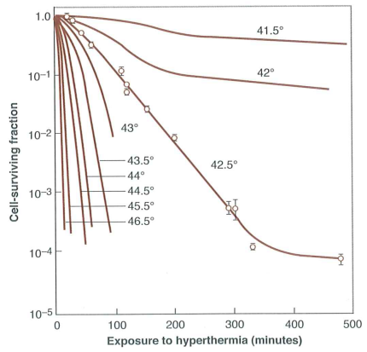
- 有關高溫治療(Hyperthermia)中，若以溫度之倒數(1/T)與D₀之倒數(1/D₀)作圖，下列何者為非？
  - 該表現符合化學反應中的Arrhenius plot
  - 溫度計算需以絕對溫度表示，且在43°C時可見明顯轉折點
  - 43°C的轉折點後，每增加1°C，可增加4-6倍細胞傷害的速率(rate of cell killing)
  - 該作圖的斜率不論在in vivo或是in vitro中都相似
    - C (Radiobiology-Hyperthermia)
      - 中等
        - Radiobiology for the Radiologist, 7th, Eric Hall—Ch 28
          - P492, “Above this temperature, an increase of 1°C doubles the rate of cell killing, and below the breakpoint, the rate of cell killing by heat drops by a factor of 2-4 for each drop of 1°C.”
Figure 28.2 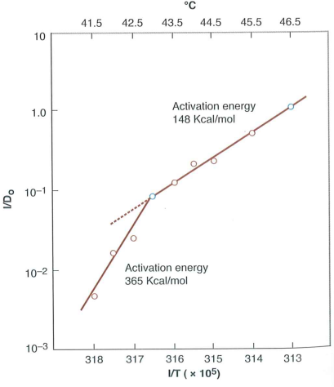
- 有關高溫治療(Hyperthermia)之描述，下列何者為誤？
  - 高溫治療主要標的物為蛋白質
  - 人類TER多約在1-2之間
  - 酒精使細胞對hyperthermia敏感；反之營養缺乏會使細胞對hyperthermia有抗性
  - 缺氧會使細胞對放射治療有抗性；但對高溫治療則影響不大
    - C (Radiobiology-Hyperthermia)
      - 易
        - Radiobiology for the Radiologist, 7th, Eric Hall—Ch 28, page 492-494
          - P.494, “Cells deficient in nutrients are quite heat sensitive.”
- 有關高溫治療(Hyperthermia)之描述，下列何者為是？
  - 理想的溫度調節(optimal thermoregulation)在41-42°C即開始失效
  - 由於thermotolerance約在治療後數小時產生，目前兩次hyperthermia間應相隔一天
  - 由於考量高溫造成的灌流下降，許多protocol採用先高溫治療再放射治療
  - 由於免疫細胞比其他細胞對溫度更敏感，因此38-39°C已使免疫反應遭抑制
    - A (Radiobiology-Hyperthermia)
      - 中等
        - Radiobiology for the Radiologist, 7th, Eric Hall—Ch 28, page 494-497
          - P.495, “Optimal thermoregulation in terms of vascular effects occurs at mild to moderate hyperthermia and begins to fail above 41 and 42°C,…”
P495, “However, it is now clear that in actual tumors in situ, an increase in blood flow and sequent increase in oxygenation by heating may significantly enhance the response of tumors to radiotherapy to a greater degree than any inhibition of thermal killing related to the occurrence of thermotolerance.”
- 有關Cumulative Equivalent Minutes，於45°C和41°C下分別暴露一分鐘，相當於43°C下暴露幾分鐘？
  - 8；1/4
  - 4；1/8
  - 4；1/16
  - 16；1/4
    - C (Radiobiology-Hyperthermia)
      - 難
        - Radiobiology for the Radiologist, 7th, Eric Hall—Ch 28, page 497
          - CEM43°C=tR^{(43-T)}; R=0.5 if T>43°C, R=0.25 if T<43°C
- 有關缺氧(Hypoxia)之描述，下列何者為誤？
  - 在真實環境，缺氧環境不一定跟腫瘤大小有關
  - 在缺氧時，HIF-1alpha藉由PHDs (prolyl hydroxylases)與HIF-1beta結合，活化下游基因
  - PHDs本身可以回饋抑制HIF的活化
  - 在氧氣濃度降至造成radioresistance前，HIF已可被啟動
    - B (Radiobiology--Hypoxia)
      - 易
        - Basic Clinical Radiobiology, 4th , Joiner M & Van der Kogel A; Ch 16, p221-2, 227
          - P.227, Figure 16.10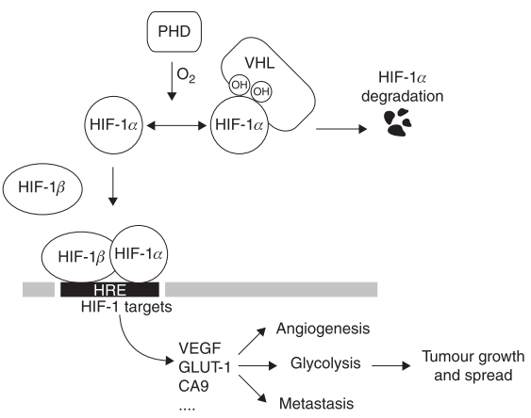
- 有關缺氧(Hypoxia)與mTOR之描述，下列何者為誤？
  - 在持久的缺氧(0.5%)下，會抑制mTOR和eIF4E，使DNA無法表達
  - 在嚴重的缺氧環境下(0.02%)，會抑制unfolded protein response，減少蛋白質和成
  - 藉由蛋白質合成減少與摺疊能力增加，可減少內質網壓力(ER stress)
  - mTOR不只是對oxygen敏感，也會對能量和營養供應產生改變
    - B (Radiobiology--Hypoxia)
      - 中等
        - Basic Clinical Radiobiology, 4th , Joiner M & Van der Kogel A; Ch 16, p. 230
          - P.230, Figure 16.12 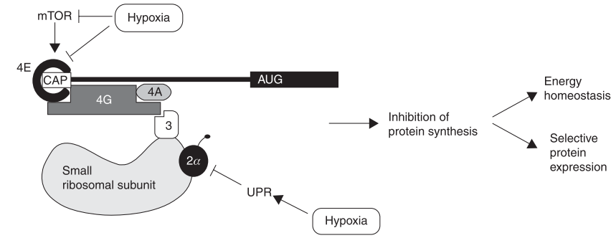
P.231, “Together, these proteins function to prevent further ER stress both by inhibiting new protein synthesis and by increasing the folding capacity of the ER.”
- 有關Checkpoint activation之描述，下列何者為誤？
  - G1→S phase的關鍵在於E2F的活化
  - S phase時接受照射，會使DNA合成時間減少
  - G2 early checkpoint，在照射G2 phase細胞時產生，低劑量即可有反應
  - G2 late checkpoint，照射所有phase的細胞皆可能產生，與劑量顯著相關
    - B (Radiobiology—Irradiation-induced damage & DNA damage response)
      - 易
        - Basic Clinical Radiobiology, 4th , Joiner M & Van der Kogel A; Ch 2, p.17-19
          - P.18, “Cells that are in S phase at the time of irradiation demonstrate a dose-dependent reduction in the rate of DNA synthesis and, as a result, the overall length of time that cells need to replicate their DNA substantially increases.”
- 有關劑量率(dose rate)之描述，下列何者為是？
Figure (a) Figure (b) (Rodent normal tissue)
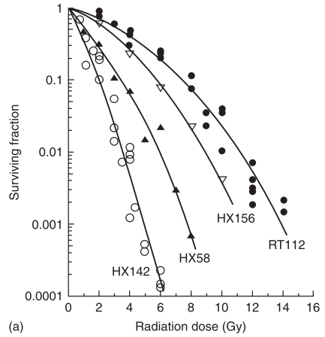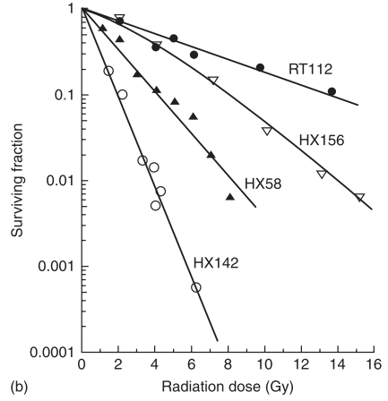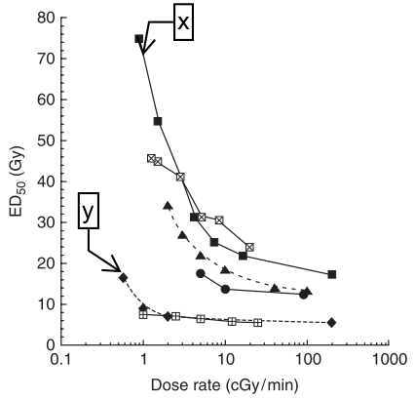
  - Dose rate：Fig (a)<(b); x=spinal cord, y=bone marrow
  - Dose rate：Fig (a)>(b); x=spinal cord, y=bone marrow
  - Dose rate：Fig (a)<(b); x= bone marrow, y= spinal cord
  - Dose rate：Fig (a)>(b); x= bone marrow, y= spinal cord
    - B (Radiobiology-Dose-Rate effect)
      - 易
        - Basic Clinical Radiobiology, 4th , Joiner M & Van der Kogel A; Chapter 12, p160-161
          - Figure 12.4 & 12.6
- 有關Inverse Dose-Rate Effect之描述，下列何者為誤？
  - 發生在1-1.5cGy/min時
  - 可增進low dose-rate permanent implants的效果
  - 是由於細胞周期累積在G2/M phase的緣故
  - 與low-dose hypersensitivity有關
    - C (Radiobiology-Dose-Rate effect)
      - 易
        - Basic Clinical Radiobiology, 4th , Joiner M & Van der Kogel A; Chapter 12, p164
          - Figure 12.9, “Analysis of the cell cycle indicates that these inverse dose-rate effects are not caused by accumulation of cells in G2/M phase or by other cell-cycle perturbations, but result from the process of low-dose hyper-radiosensitivity”
- 有關放射治療中的早期反應(early radiation effect)之描述，下列何者為誤？
  - 較嚴重的反應通常在高劑量時發生，且潛伏期(latent time)較長
  - 潛伏期(latent time)不但與劑量有關，也與組織本身特性有關
  - 隨劑量增加，transit proliferation會減少
  - 由於abortive division，通常turnover time比latent time短
    - B (Radiobiology-Early Radiation effects)
      - 中等
        - Basic Clinical Radiobiology, 4th , Joiner M & Van der Kogel A; Chapter 13, p172-173
          - Figure 13.3
P.173, “As the cell loss rate depends on the turnover time of the tissue, and is independent of the treatment, the latent time until a clinical response is reached is tissue-dependent but independent of dose.”
P.173, “Hence, increasing radiation doses result in a progressive decline in the number of precursor cells available for differentiation into post-mitotic cells.”
- 有關下圖之描述，下列何者為是？
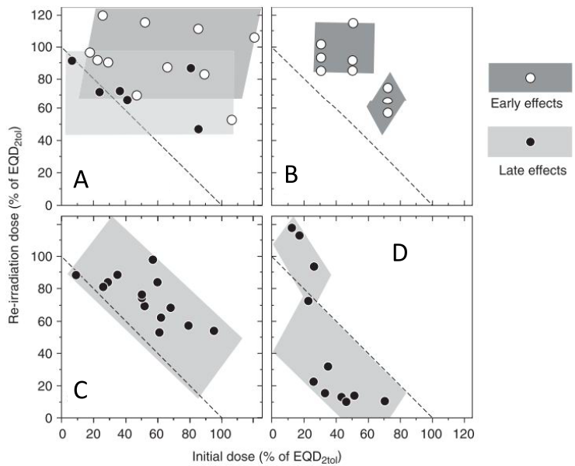
  - A—Lung pneumonitis；B—Oral mucosa；C—Spinal cord；D—Kidney
  - A—Oral mucosa；B—Lung pneumonitis；C—Kidney；D—Spinal cord
  - A—Lung pneumonitis；B—Oral mucosa；C—Kidney；D—Spinal cord
  - A—Oral mucosa；B—Lung pneumonitis；C—Spinal cord；D—Kidney
    - D (Radiobiology—Re-irradiation)
      - 易
        - Basic Clinical Radiobiology, 4th , Joiner M & Van der Kogel A; Ch 19, p267
          - P.267, Figure 19.11 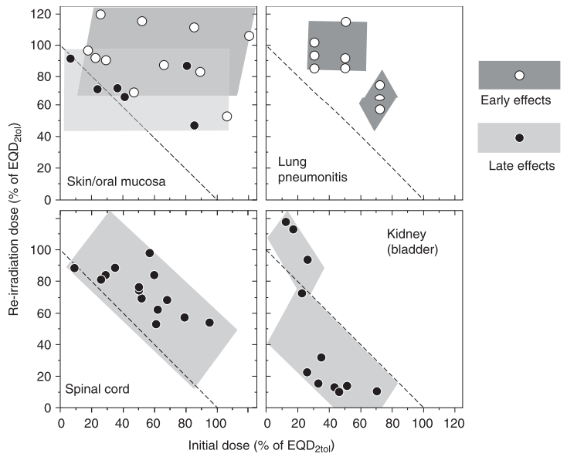
- 有關urinary bladder放射線傷害之描述，下列何者為誤？
  - 在動物實驗，early phase的第一階段與prostaglandin有關，可使用aspirin緩解
  - 在動物實驗，early phase的第二階段與上皮細胞損失有關，會引發感染
  - 在動物實驗，再次照射(re-irradiation)的潛伏期(latent time)明顯較短
  - 在動物實驗，若欲產生相同晚期反應，再次照射的劑量不隨時間間隔拉長而增加
    - B (Radiobiology—Radiation effects & Re-irradiation)
      - 中等
        - Basic Clinical Radiobiology, 4th , Joiner M; Ch 13, p.185 & Ch 19, p265
          - P.185, “Experimentally, in mice, two waves of early injury have been observed.” “The second early phase is associated with changes in urothelial barrier function, but without epithelial cell depletion (which is not expected at this time because of the very long turnover time of the urothelium).”
- 有關bone marrow之描述，下列何者為誤？
  - 在高劑量(ex, TBI)放射照射後，骨髓中造血幹細胞與基質部分皆無法再生
  - 在高劑量(ex, TBI)放射照射後，骨髓將由fatty tissue取代
  - 在中劑量放射照射後，周邊血球數的上升不能代表骨髓造血幹細胞的恢復
  - 相對於骨髓中造血幹細胞，基質部分的恢復較快
    - D (Radiobiology—Re-irradiation)
      - 易
        - Basic Clinical Radiobiology, 4th , Joiner M & Van der Kogel A; Ch 19, p262
          - P.262, “Restitution of stromal elements, which closely interact with the stem–progenitor cell system in the bone marrow, may take even longer than for the haematopoietic system itself.”
- 有關放射性恐怖主義(Radiologic Terrorism)之描述，下列何者為誤？
  - 髒彈(Dirty Bomb)指的是radiologic dispersal device，由傳統爆裂物與放射物質構成
  - 放射物質可由煙霧偵檢器、土壤水分儀中取得
  - 外部暴露(external exposure)指的是放射性物質附著在身體的表面
  - 進入體內的放射物質可由尿液檢驗中測得
    - C (Radiobiology-Radiologic Terrorism)
      - 易
        - Radiobiology for the Radiologist, 7th, Eric Hall—Ch 14
          - P.197, “External contamination refers to radioactive material on the surface of the body.”

